**Unified Modeling Language Diagrams = UML**

**Extension 2: multiplicity**

* It is a specification of the number of possible occurrences of a property, or the number of allowable elements that may participate in a given relationship. (*)
* Minimum:
  + Mandatory: 1
  + Optional: 0
* Maximum:
  + Forbidden: 0
  + Only one: 1
  + Many: -*
* Represented as min...max pairs: 0..0, 0..1, 0..*, 1..1, 1..*

**Multiplicity, cont.**

For each association, multiplicity specifies the rules about the number of times one class is related to the other

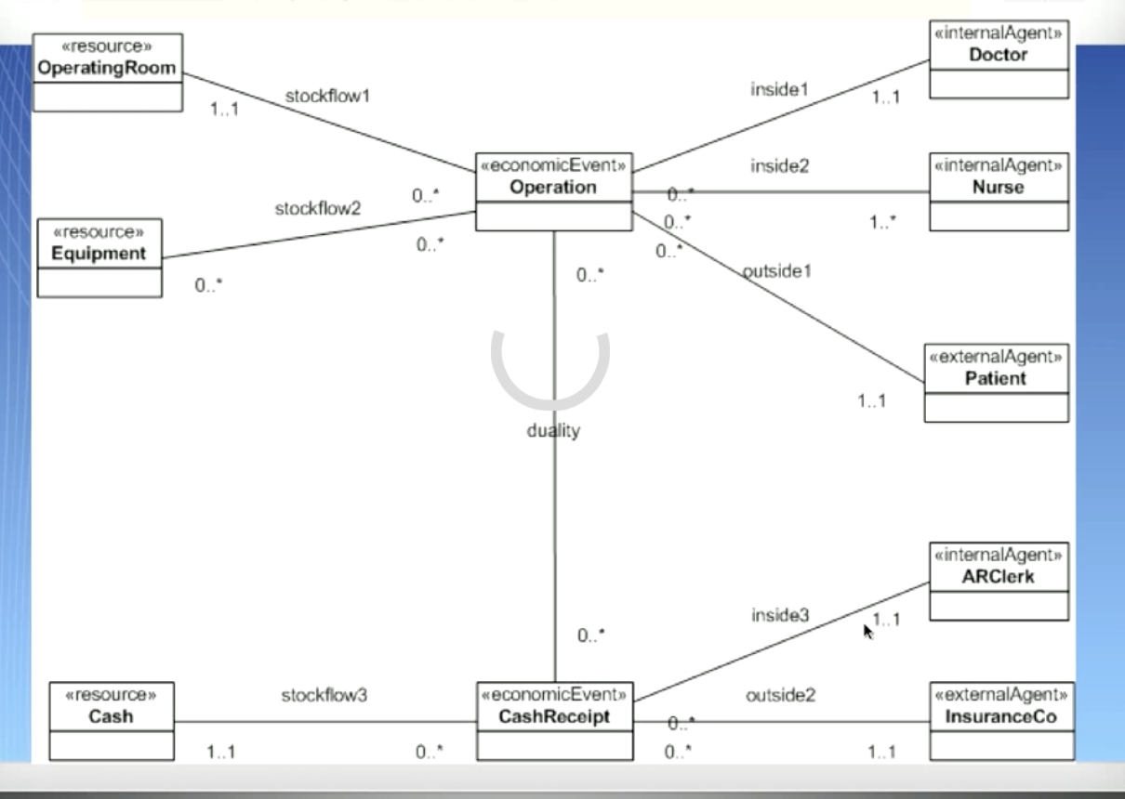

**Conceptual modelling:** UML and modelling patterns

Models: from reality to system UML revisited (modelling patterns in next presentation)

Building the “right” system

Universe of discourse > conceptual model (cm) > use of CM

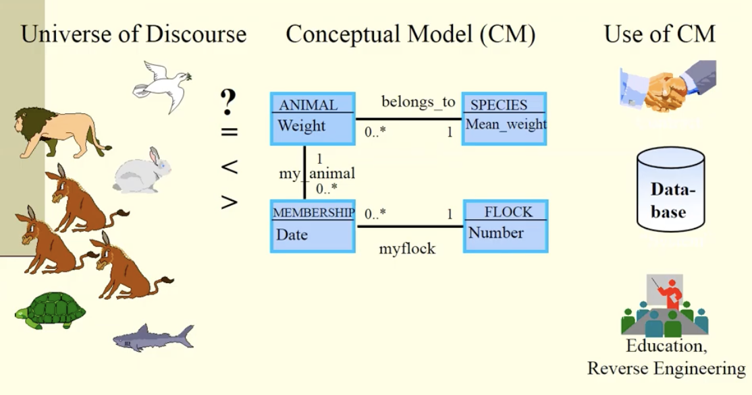

Models- true? false? Good? Problematic ?

Model: a structure -map of some part of reality ?

Example of a model : a map

Models simplify

Models distorts - greenland, africa

Models focus and highlight - topograpically，politically, etc.

Modelling languages: